

**BACHELOR OF INFORMATION TECHNOLOGY (HONS)**

**BIT304**

**Final Year Project I**

## PROJECT PLAN

**Ayo Magang: Web Application for Internship in Denpasar**

|  |  |
| --- | --- |
| **Student Name: Rivaldo Bagus Soepardhy** | **Student ID: E1700882** |
| **Student Name: Luh Wulandari Maharani** | **Student ID: E1700873** |

**15 Jalan Sri Semantan 1, Off Jalan Semantan, Bukit Damansara, 50490 Kuala Lumpur, Malaysia.**

**Tel : 603-2716 2000, Fax : 603 - 2095 7100**

1. **PROJECT TITLE**

Ayo Magang: Web Application for Internship in Denpasar

1. **PROJECT MEMBERS**

|  |  |  |
| --- | --- | --- |
| **No** | Student ID | **Name** |
| 1 | E1700882 | Rivaldo Bagus Soepardhy |
| 2 | E1700873 | Luh Wulandari Maharani |

1. **PROJECT KEY WORDS**

* Internship
* Jobs
* Internship Service
* Website
* Academic

1. **PROJECT BACKGROUND**

Internships are job-training activities carried out by vocational high school or college students in a company or institutions in both government and non-government. With internship, vocational high school and college students can add insight, knowledge, skills and ethics (academic purpose), especially in the real work environment. Not only vocational high school and college students will get the benefits from this internship, but companies and related institutions will also get benefits such as increasing branding and finding prospective employees easily.

In the current era of digitalization, the public, especially vocational high school and college students, want ease in accessing various information, one of them is accessing information on internships. Where vocational high school or college students who have just a little or even no relations, still can find the right internship easily.

Ayo Magang is a web-based apprenticeship application created specifically to facilitate vocational high school and college students to find internships around Denpasar city, which are desired according to their field of expertise. Companies and related institutions will find the desired employees easily and can save on expenses.

1. **AIMS OF THE PROJECT**

The aim of this project is to develop an application for vocational high school and college students to find internship in companies for academic purpose. This also ease companies to get interns to work in their company for the sake of educational purpose or even company’s branding. This application helps student to find the desired company for internship in order to fulfil the demand of their school’s or campus’s academic. This application can also determined which company to get along with according to the course of your education stated in your profile (Hospitality, Technology, Medical etc.).

It is expected from this application that this could help student in trouble or confusing situation to consider which workplace will be a good place for their internship, while also helping companies to get better branding and to find potential employee through the internship.

1. **OBJECTIVES OF THE PROJECT**

There are several objectives that we set to develop Ayo Magang application, which are:

* Providing information for vocational high school and college student about relatable workplace for their academic internship.
* Providing a media for company to have company branding (advertisement).
* Providing a media for company indirectly to recruit and train potential prospective employees from the internship.
* Providing an indirect potential relationship between both educational institutes and companies.
* Providing real evidence to support increased of investment in human resource, marketing, and technology.

1. **DIRECT CUSTOMERS/BENEFICIARIES OF THE PROJECT**

This application is intended for vocational high school & college student to find their preferred place of workplace for academic internship. Although the focus of the application is for academic reason, but there is still an opportunity for business; Branding and Relationship. Through the application, companies will indirectly branding their selves because of the vacancies that they offer for student for academic internship. In addition, there will be potential relationship between companies and school as they can exchange trainee (or recruit perspective employee), or developing a project.

1. **OUTPUTS EXPECTED FROM THE PROJECT**

Details of works and tasks done by each team member:

* + - * 1. Rivaldo Bagus Soepardhy
* Develop project objectives
* Project aims & objectives
* Literature review
* Risk management
* Prototype
* Use case development
* Class diagram and Sequence diagram development
* Software methodology development
* Functional & non-functional requirements development.
  + - * 1. Luh Wulandari Maharani
* Project background development
* Resource plan list
* Literature review
* Project Schedule development
* Develop database design
* Developing Work Item List
* Requirement gathering
* Prototype
* Use case development
* Class diagram and Sequence diagram development
* Functional & non-functional requirements development.

1. **ORGANISATIONS/INDUSTRIES INVOLVED IN THE PROJECT** 
   1. ITB STIKOM Bali
   2. HELP University
2. **SYSTEM DEVELOPMENT METHODOLOGY**

The choice for our methodology for our system development is Agile Methodology. The Agile Methodology is well known for its popular framework called Scrum that simplifies the work process and focusing on teamwork. The benefits that we highlight the most from this framework is for its adaptation with any technology, more room for trial and error, and the constant feedback in-between development. (Adell, 2013).

With the advantages we mentioned, it will an obvious reason we choose this methodology. The simplified process, mistakes than can be easily rectified (Adell, 2013), the adaptation to technology makes it better for the best option. What the most unexpected problem from project is sometimes changes in basic design or even reconstructing the whole code, that not many methodology allows but Agile. Moreover, we believe with constant feedback that we can get from stakeholders whether from users or developers, Scrum will allow us to adapt with changes, a good point for cycle of improvement, provide times for improvement, refinement, or even a whole change to the development. The teamwork will also give enough effect to the project as the methodology demand communication & coordination between members for the sake of better developing

## RISK MANAGEMENT PLAN

|  |  |  |  |  |
| --- | --- | --- | --- | --- |
| No | Description | Probability % | Impact  1= low  5 = high | Mitigation Strategy |
| 1 | Lack of experience, skills, and knowledge in developing a website application using Laravel Framework or PHP Native. | 45 | 5 | Find online source regarding PHP and Laravel framework, exploring plans and option in between deciding which method is the best. |
| 2 | The website might have bugs or unexpected errors occurred. | 30 | 4 | Performing testing (unit testing, system testing and integration testing) for early detection of bugs and errors that might happen. |
| 3 | The website might not be done on deadline. | 50 | 5 | Talk efficiently, catching up schedules and communicating with members and lecturers. Held only important meetings (necessary only). |
| 4 | UML Diagram produced might not show the proper workflow of the system, creating misunderstanding. | 35 | 3 | Reconsidering and checking out to basic design of the system. Get more consultation to lecturer. Re define each use case / action required in each design. |
| 5 | Errors undetected in the final release or future development | 10 | 3 | Error logging on the system, documentation documents. |

**12. WORK ITEMS LIST**

|  |  |  |  |
| --- | --- | --- | --- |
| **Phases and Activities** | **Priority** | **Assigned To** | **Effort Estimated (days)** |
| * + - 1. **Initiating** | | | |
| * 1. Online Meeting with Supervisor | High | Aldo and Wulan | 1 |
| * 1. Project Theme Identification | High | Aldo and Wulan | 1 |
| * 1. Consultation with Supervisor | High | Aldo and Wulan | 1 |
| 1. 4 Project Theme Decision | High | Aldo and Wulan | 0 |
| * + - 1. **Planning** | | | |
| 1. Develop Project Background | High | Wulan | 1 |
| 1. Develop Project Aims and Objectives | High | Aldo and Wulan | 1 |
| 1. Develop Work Item List | Medium | Wulan | 2 |
| 1. Develop Project Schedule | Medium | Wulan | 1 |
| 1. Software Methodology | Medium | Aldo | 1 |
| 1. Develop Resource Plan | Medium | Wulan | 1 |
| 1. Risk Management Plan | High | Aldo | 1 |
| 1. Submission of Project Plan | High | Aldo and Wulan | 1 |
| * + - 1. **Executing** | | | |
| 1. Develop Literature Review | High | Aldo and Wulan | 5 |
| 1. Develop Project Management Plan | High | Aldo and Wulan | 5 |
| 1. Chapter II: Literature Review and Project Management Plan Submission | High | Aldo and Wulan | 1 |
| 1. Preparation for Interim Presentation | Medium | Aldo and Wulan | 5 |
| 1. Interim Presentation | High | Aldo and Wulan | 1 |
| 1. Develop Requirement Analysis | High | Aldo and Wulan | 2 |
| 1. Develop Functional and Non-Functional Requirements | High | Aldo and Wulan | 2 |
| 1. Develop Use Case Diagram | Medium | Aldo and Wulan | 2 |
| 1. Chapter III: Requirement Analysis Submission | High | Aldo and Wulan | 1 |
| 1. Develop Class Diagram | High | Aldo and Wulan | 1 |
| 1. Develop Sequence Diagram | High | Aldo and Wulan | 1 |
| 1. Database Design | Medium | Aldo and Wulan | 1 |
| 1. Structural Design | Medium | Aldo and Wulan | 1 |
| 1. User Interface Design | High | Aldo and Wulan | 1 |
| * + - 1. **Construction** |  |  |  |
| 1. Coding for Prototype | High | Aldo and Wulan | 2 |
| 1. Testing | High | Aldo and Wulan | 1 |
| 1. Chapter IV: Iteration Submission | High | Aldo and Wulan | 1 |
| * + - 1. **Closing** |  |  |  |
| 1. Develop Progress Report | High | Aldo and Wulan | 3 |
| 1. Preparation for Final Report Submission | High | Aldo and Wulan | 2 |
| 1. Final Report Submission | High | Aldo and Wulan | 1 |
| 1. Preparation for Final Presentation | High | Aldo and Wulan | 3 |
| 1. Final Presentation | High | Aldo and Wulan | 1 |

1. **WORK PLAN**

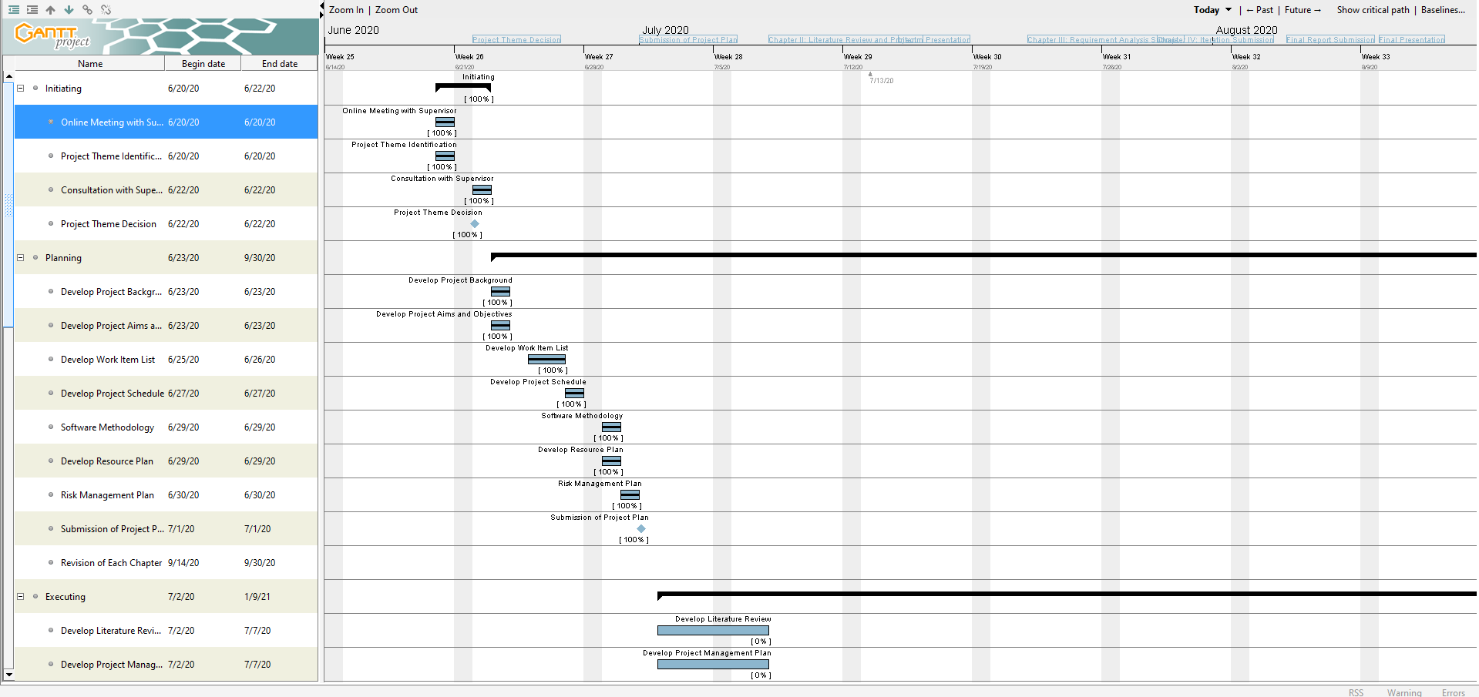

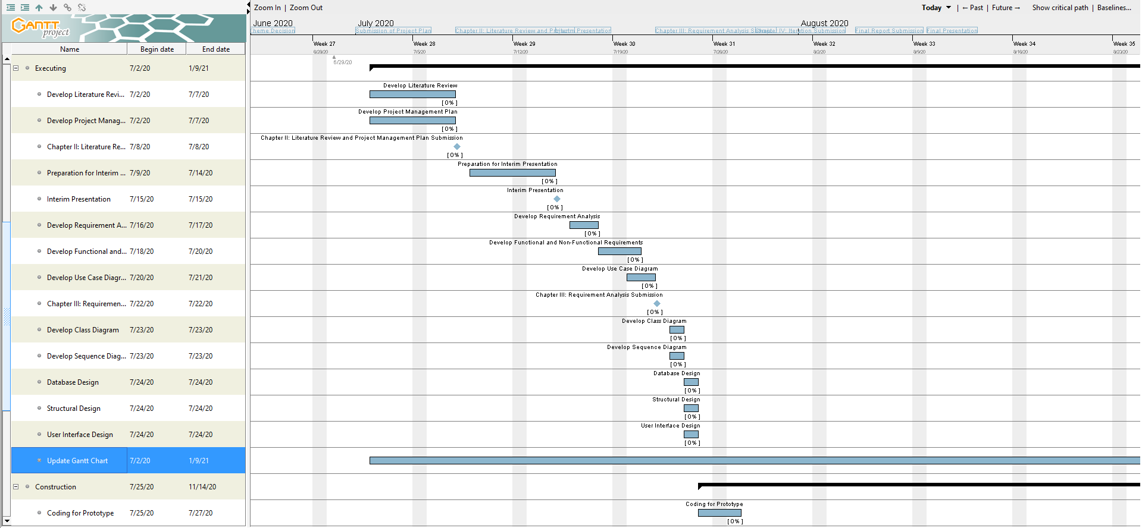

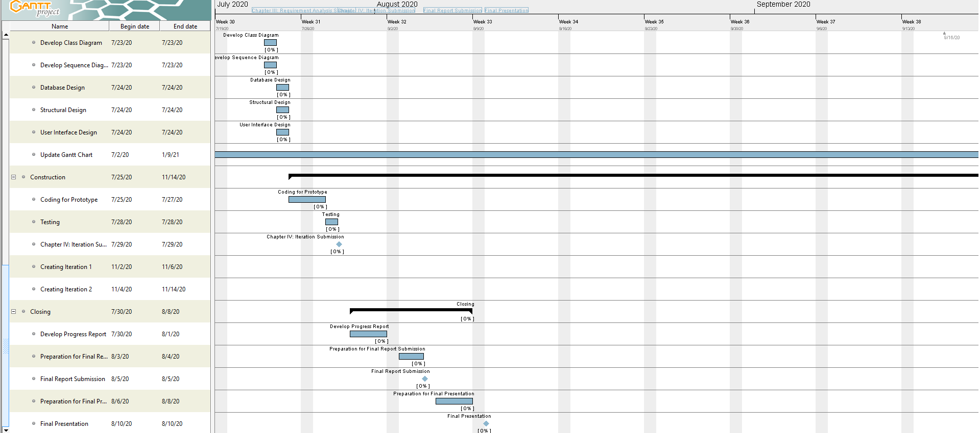

1. **DURATION**

BIT304 – Final Project 1

Start Date: June 20th, 2020

End Date: August 9th, 2020

BIT305 – Final Project 2

Proposed Start Date: September 21st, 2020

Proposed End Date: January 2020

1. **FUNDING SOURCE**

There is no funding source at the moment.

1. **PROJECT RESOURCE REQUIREMENTS AND ESTIMATED COSTS\***

|  |  |  |  |  |
| --- | --- | --- | --- | --- |
| **No** | **Item** | **Usability** | **Qty** | **Cost** |
| **Hardware** | | | | | |
|  | Asus VivoBook S14-410UN | Project Development & Project Testing | 1 | Available |
|  | Asus ROG GL503GE | Project Development & Project Testing | 1 | Available |
|  | Canon G2010 | Document Printing | 1 | Available |
| **Operating System** | | | | |
|  | Windows 10 | Project Development & Project Testing | - | Available |
| **Software** | | | | |
|  | Adobe XD CC 7.0.12.9 | Create interface design | - | Available |
|  | Microsoft Visio 2016 | Drawing UML Diagram | - | Available |
|  | Microsoft Word 2016 | Create project document | - | Available |
|  | Microsoft PowerPoint 2016 | Create presentation for the project | - | Available |
|  | XAMPP 7.4.3-0 | Database Creation | - | Available |
|  | Gantt Project 2.8.1 | Create project schedule | - | Available |

1. **CONTRACTUAL OBLIGATIONS UNDER THIS PROJECT**

**Team member:**

* Rivaldo Bagus Soepardhy (E1700882)
* Luh Wulandari Maharani (E1700873)
  + - * 1. **Participation**

As a team, we will:

* Responsible and finished the task
* Help to solve problems and giving solution
* Present in every meeting
* Work together to do the task
  + - * 1. **Problem Solving Skill**

As a team, we will:

* Communicate about the project problem and giving an advice
* Giving an opinion if anything is not understood
* Respect each other
  + - * 1. **Communication**

As a team, we will:

* Discuss about project goals clearly
* Discuss about project ideas
* Discuss about project problems and giving a solution
  + - * 1. **Code of Conduct**

As a team, we will:

* Has a good relation with others to support each other as a teamwork
* Work together to solve all project problems
* Distribute tasks and work items equally

1. **OWNERSHIP OF INTELLECTUAL PROPERTY RIGHTS**

All ownership and intellectual property belongs to HELP University.

**PROJECT MEMBERS DECLARATION**

We hereby acknowledge that the all the information given above is true and correct to the best of our knowledge.

**Name :** Rivaldo Bagus Soepardhy

**Signature :**

**Date :**

**Name :** Luh Wulandari Maharani

**Signature :**

**Date :**

## References

Adell, L. (2013, April 11). *Benefits and Disadvantages of Scrum Methodology in Software Development*. Retrieved from Belatrix: https://www.belatrixsf.com/blog/benefits-scrum-software-development/

Appendix A: Team Members’ Contributions

|  |  |
| --- | --- |
| Student Name | Contribution[1] |
|  |  |
|  |  |
|  |  |

1. **Enter** **each individual student’s contribution (eg. 0.5 for 'half' contribution or 1 for 'full' contribution). The examiner will award a shared group mark, which is adjusted according to the peer assessment factor. The individual student's mark is based on the group mark multiplied by the peer assessment factor (eg. X 0.5 for 'half' contribution or X 1 for 'full' contribution).**